# **POPal AI tool**

Auto generate Jira Issues Epics, User Stories, Test Cases, and Test Automation Scripts with AI (ChatGPT) and save your time.

## Features

* **Refine Epic and Breakdown Epic to user stories.**

AI backlog generator helps you update Epic into proper format including benefit hypothesis and acceptance criteria. And automatically generates multiple user stories with title, story, and acceptance criteria.

* **Refine User stories.**

AI backlog generator refining user stories, transforming them along with acceptance criteria. With enhanced clarity, it makes Backlog refinement and sprint planning more effective, and reduces the rework.

* **Generate Test Cases and Test Automation Scripts.**

AI backlog generator automatically generates comprehensive test cases as ‘Test Case’ issue type. In addition, it generates test automation scripts as well.

## Steps

* From the actions 3 dots menu, click on the Generate item.

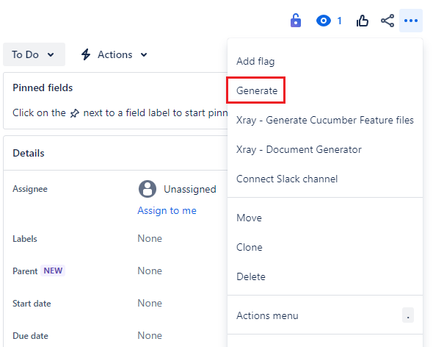

* The user can choose the action from the window.

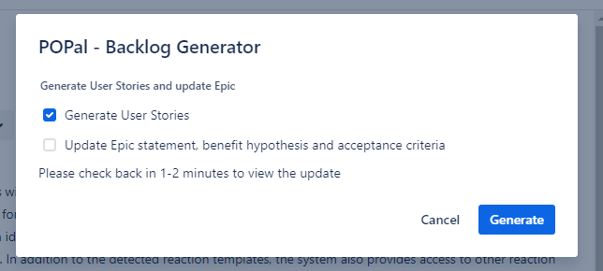

* The user will need to refresh the page to see the updates.

## Samples

1. Work on Epic with description.
2. Work on Epic with Description and images.

### Work on Epic with description.

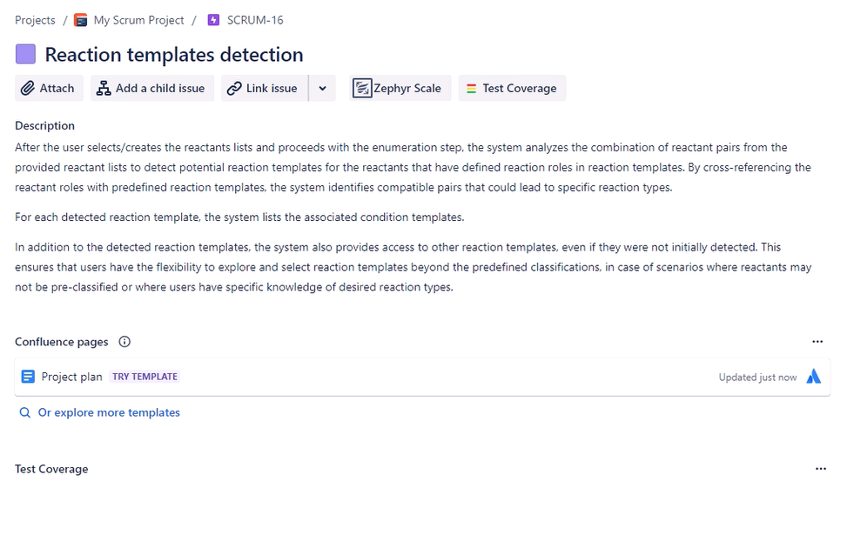

**After the POPal tool:**

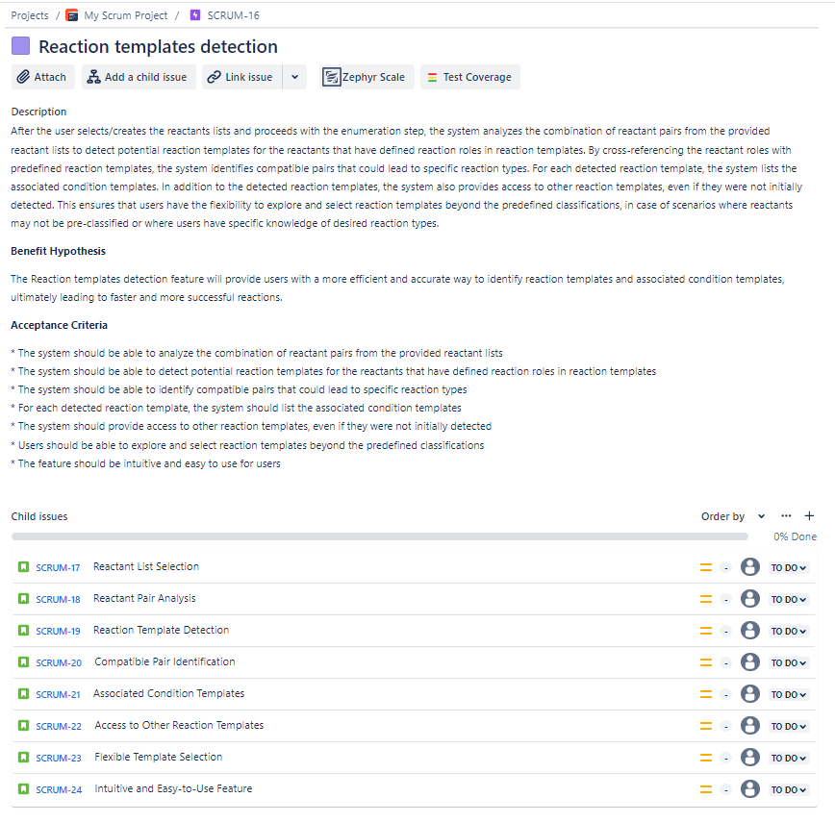

* The Epic has been updated and adding the benefit hypothesis and acceptance criteria.
* The user stories have been created.
* Every user story has description and acceptance criteria.
* Accuracy:
  + 1 out of the scope (can delete it)
  + Cover 100% according to the description.
    - Note: some of the user stories can be handled in one

### Work on Epic with Description and images.

* The Epic has been updated and adding the benefit hypothesis and acceptance criteria.
* The images have been removed.
* The Benefit Hypothesis is better than the first one.
* The same acceptance criteria
  + There is one extra point in the first related to usability.
* The User storied in the first one is better (more coverage and the description are clear than the second one)
  + The out of the scope TC is not created.
  + The usability TCs are not created.
  + The description in the first one is clearer than the second one.